EMIS Access the convenient way to book or cancel appointments with GPs at Old Machar Medical Practice.

Ease of use
EMIS Access is an appointment booking service which has been carefully designed for ease of use, and can be used by anyone who has a computer, mobile phone or digital TV.

It’s quick and easy to use, and can be particularly useful during those times when the practice is closed, telephone lines are busy or if you are away from home. The easy to follow screens and prompts ensure it’s simple for you to view, book, or cancel appointments online – whatever time of the day or night.

Using EMIS Access, you will be able to view a range of available appointments and choose the most convenient time for you.

Secure information
All personal information contained on EMIS Access is protected using the highest standard internet security. Before you can start booking appointments online, you must first register your details for this service.

Registering for the service

It’s quick and easy to register – simply follow the three steps below.

Step 1. Complete an application form. These can be obtained from reception or from the practice website in the “Make Appointment” page. These must then be returned to the practice and you will be provided with the appropriate registration form with PIN and ID numbers to use the EMIS Access facilities.

Step 2. Choose the media that you want to use:

Internet: go to the practice website www.oldmachar.co.uk and click on the link which can be found on the “Make Appointment” page.

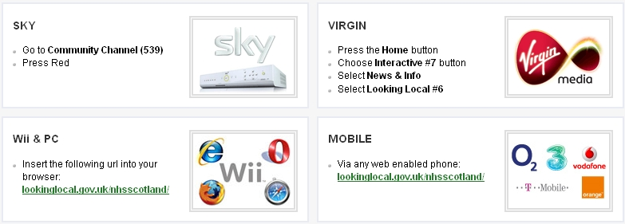

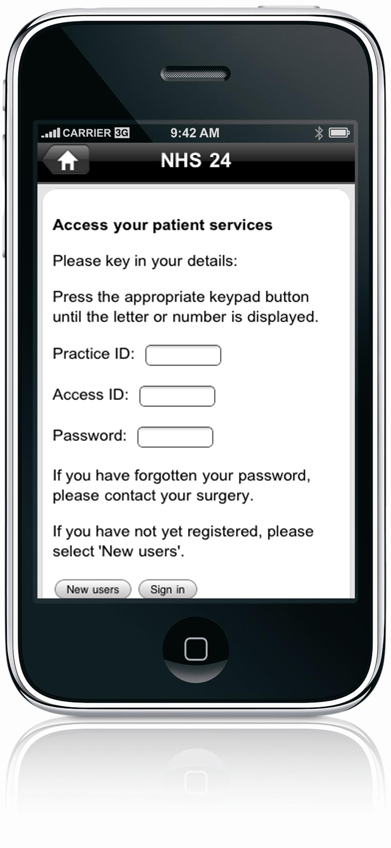

Smartphone: Downloading the free “looking local” app for iphone or android.

Step 3. Create your account.

NOTE: Depending on the media used the screens will be different. If using media other than the internet, go though the screen selecting the appropriate options, then select NHS Scotland and NHS 24 this will take you to GP Services. Select use GP Services and enter your personal registration details exactly as they appear on the registration form. If the information does not match, your registration with not be accepted.

You are now ready to book and cancel appointments.

Once registered, simply log on with your practice ID, patient ID and password. You can view any appointments you have already made, cancel them if necessary, or book a new appointment after checking which times are available.

There is no need to re-confirm by email or telephone – just arrive promptly on the day.

