EMIS Access the convenient way to book
or cancel appointments with GPs and
Nurses

Ease of use
EMIS Access is an appointment booking service which has been carefully designed for ease of use, and can be used by anyone who has a computer, mobile phone or digital TV and developed in partnership with NHS 24 and Looking Local.

It’s quick and easy to use, and can be particularly useful during those times when the practice is closed, telephone lines are busy or if you are away from home. The easy to follow screens and prompts ensure it’s simple for you to view, book, or cancel appointments online – whatever time of the day or night.

Using EMIS Access, you will be able to view a range of available appointments and choose the most convenient time for you.

Secure information
All personal information contained on EMIS Access is protected using the highest standard internet security. Before you can start booking appointments online, you must first register your details for this service.

It’s quick and easy to register – simply follow the three steps below.

Remember, when using EMIS Access all your personal information is safe and secure.

Register in three easy steps
1. Ask at reception for a registration form. This provides all the information you need to register to use the EMIS Access facilities.

2. Choose the media that you want to use:
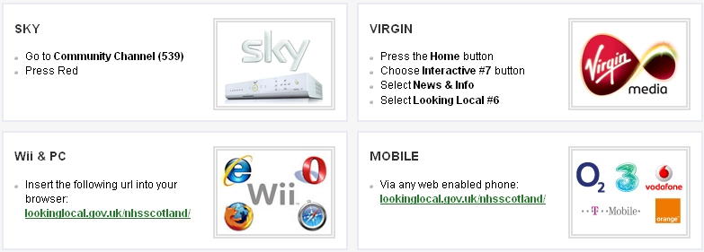

Other options include using the internet, go to the practice website www.dollarhealthcentre.org.uk and click on the link.
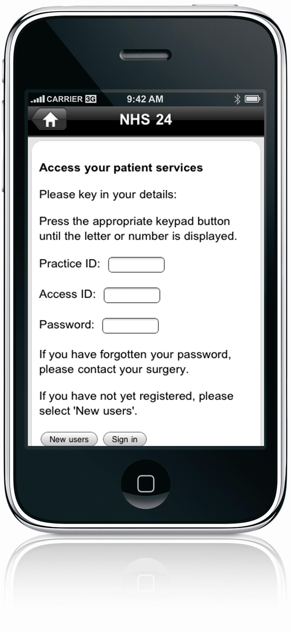
Or downloading an app from itunes if you have an iphone and the android app should be available soon.
Just search under looking local or text your postcode to 61061.

3. Create your account and get started.

