EMIS Access the convenient way to book or cancel appointments with GPs and Nurses

Ease of use
EMIS Access is an appointment booking service which has been carefully designed for ease of use, and can be used by anyone who has a computer, mobile phone or digital TV and is being developed in partnership with NHS 24 and looking local.

It’s quick and easy to use, and can be particularly useful during those times when the practice is closed, telephone lines are busy or if you are away from home. The easy to follow screens and prompts ensure it’s simple for you to view, book, or cancel appointments online – whatever time of the day or night.

Using EMIS Access, you will be able to view a range of available appointments and choose the most convenient time for you.

Secure information
All personal information contained on EMIS Access is protected using the highest standard internet security. Before you can start booking appointments online, you must first register your details for this service.

It’s quick and easy to register – simply follow the three steps below.

Remember, when using EMIS Access all your personal information is safe and secure.

Registering is three easy steps

Step 1. Ask at reception for a registration form. This provides all the information you need to register to use the EMIS Access facilities.

Step 2. Choose the media that you want to use:
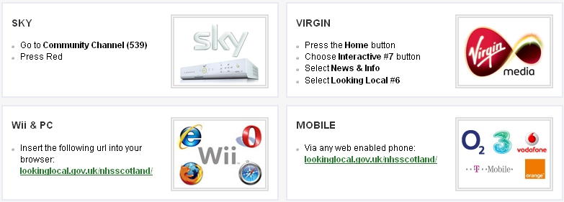

Other options include using the internet, go to the practice website www.dollarhealthcentre.org.uk and click on the link.
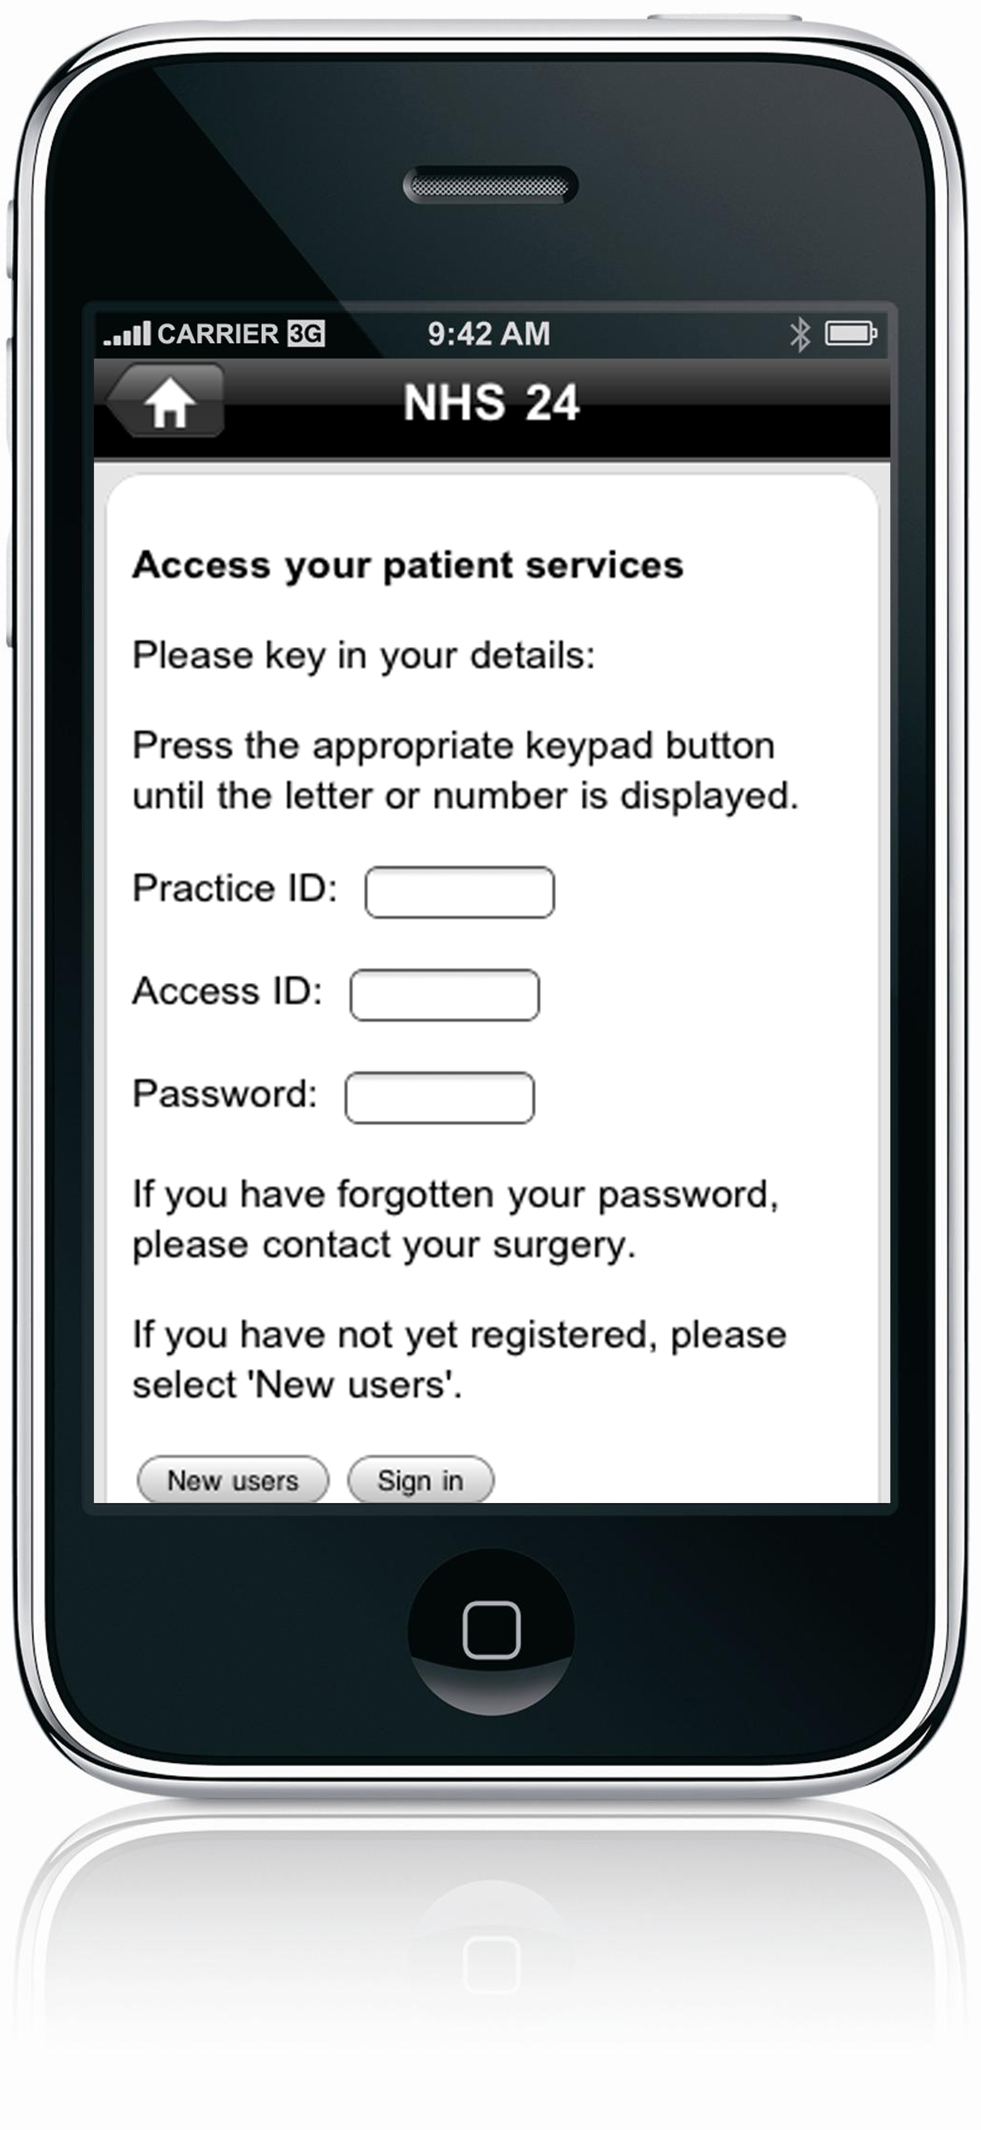
Or downloading an app from itunes if you have an iphone and the android app should be available soon.
Search for the free looking local app or text your postcode to 61061.

Step 3.
Create your account.

Depending on the media used the screens will be different. If using media other than the internet, go though the screen selecting the appropriate options, then select NHS Scotland and NHS 24 this will take you to GP Services. Select use GP Services and enter your personal registration details exactly as they appear on the registration form. If the information does not match, your registration with not be accepted.

You are now ready to book and cancel appointments.

Once registered, simply log on with your practice ID, patient ID and password. You can view any appointments you have already made, cancel them if necessary, or book a new appointment after checking which times are available.

There is no need to re-confirm by email or telephone – just arrive promptly on the day.

You can also use our website www.dollarhealthcentre.org.uk to order repeat medication. Alternatively you can go to Lloyds and register for the chronic medication service (CMS) and after registration you will only need to collect you medication from them – no need to contact us first to request it.

Information about booking of on the Day appointments

We introduced on the day appointments with the duty team (a Nurse Practitioner and GP) to improve access to medical services at the Practice. The service provision is that if you contact us before 10:15am on the day you wish to be seen or have a telephone consultation, we will guarantee that you will have the consultation that morning.

We appreciate that it can be difficult to get through on the telephone early in the morning, and are introducing pre-booking of on the day appointments in increase booking options.

Please read the following guidance notes about booking on the day appointments online.

- Booking is available from 6pm the night before the appointment.

- Although entering a reason is optional in Emis Access - for on the day appointments we do require you to enter a reason. This helps the duty team evaluate who is the most appropriate person for you to consult with. (This may not be available on all media).

- If you want to have a telephone consultation, please also enter a telephone number that you can be contacted on into the reason.

- Appointments Tuesday to Thursday between 8:30am – 9:30am are with the Nurse Practitioner.

