
EMIS Access is the new and convenient way to book appointments for GPs and Nurses over the internet

Book your next appointment online
It’s quick and easy to use, and can be particularly useful during those times when the practice is closed or telephone lines are busy or if you are away from home.

Easy to follow screens and prompts ensure it’s simple for you to view, book, or cancel appointments online – whatever time of the day or night.

Ease of use
EMIS Access online appointment booking has been carefully designed for ease of use, and can be used by most internet browsers. It is even possible to use EMIS Access from some mobile phones.

Using the internet, you will be able to view a range of available appointments and choose the most convenient time for you.

Other internet features
The popularity of online appointment booking has led to extra features being introduced to help patients with busy lifestyles communicate more easily with their GP practice.

Secure information

All personal information contained on EMIS Access is protected using the highest standard internet security.

Before you can start booking appointments online, you must first register your details for this service.

It’s quick and easy to register – simply follow the three steps below.

Remember, when using EMIS Access all your personal
information is safe and secure.

Register in three easy steps

Step one:
Ask at reception for a registration form. This provides all the information you need to register to use the EMIS Access internet facilities.

Step two:
Visit the practice website at: www.dollarhealthcentre.org then click on the logo toward the bottom of the page. This opens the online access screen,

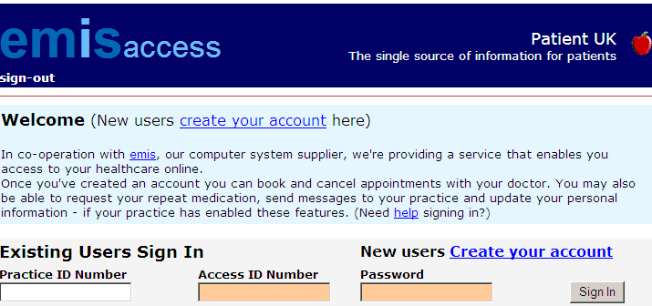

Simply select ‘create your account’.

Step three:
Enter your personal registration details exactly as they appear on the registration form. If the information does not match, your registration will not be accepted.

You are now ready to book appointments online

Once registered, simply log on with your practice ID, patient ID and password. You can view any appointments you have already made, cancel them if necessary, or book a new appointment after checking which times are available.

When you book an appointment online, you will receive confirmation immediately. There is no need to re-confirm by email or telephone – just arrive promptly on the day.

You can also use the website to order repeat medication

