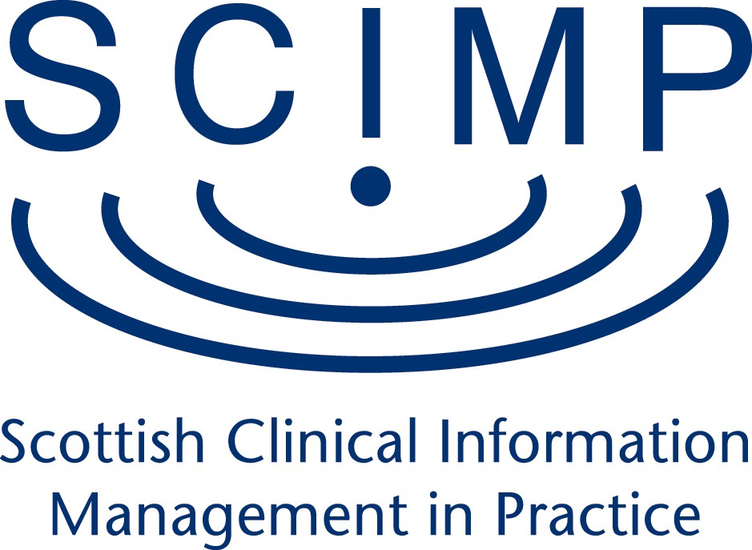

Minutes of the SCIMP Board meeting at 14.00 on Tuesday 27th March in Meeting Room 6, Gyle Square

Present : Sheena MacDonald (SMcD) Chair Bob Milne (BM)
Libby Morris (LM) Teleconference
Eileen Dargo (ED)
Annabel Chambers (AC) Secretariat

- Apologies

Apologies were received from Hester Ward (HW), David Knowles (DK), Karen Young (KY), Richard Copland (RC) and Duncan Buchanan (DB).

- Minutes of meeting 6th December 2011

The minutes of the meeting were accepted as an accurate record.

- Actions from previous minutes

Recurring funding for SCIMP – The SCIMP Funding paper has now been agreed and signed off at PCPMG. Funding from SGHD Primary Care Department is to come into ISD via NISG on a recurring basis and SMcD agreed to have a discussion with KY and Andy Robertson, NISG regarding this.
Action : SMcD

Guidance for Practices on Summarising/Advice for practices regarding transfer of information for deducted patients/ PSD Acceptable file types (White List) – it has been agreed to have a special PCPMG on 4th May to discuss these areas and other actions from the last docman project board. LM will also meet to have a preliminary discussion with PSD/SGPC/SCIMP on 12th April. LM agreed to provide an estimate of the funding which would be required for this work.
Action : LM

4. Update from recent PC PMG meetings

SMcD agreed to have a further discussion regarding the unique identifier for prescribers at SGHD and report back.
Action : SMcD

5a. Membership of SCIMP/Chair of SCIMP

SCIMP provided a draft job description for the Chair of SCIMP, a paper outlining options for appointing a new Chair and a draft Annual Report for 2011/12.

It was recognised that the SCIMP Chair has a clinical leadership role within SCIMP and SMcD and LM agreed to have discussions within SGHD on how to appoint a new Chair to SCIMP. SMcD will also discuss with KY, AR as part of her SCIMP/NISG budget discussions.

5b. Remit of SCIMP Board/SCIMP Working Group

As part of the discussions around the draft SCIMP Annual Report, the remit of the SCIMP Board and the SCIMP Working Group were discussed. It was agreed that there was a need for the continuance of the SCIMP Working Group and its work. It was, however, recognised that the majority of the members of the SCIMP Board were also members of the PC PMG and therefore it was agreed that this overlap would be discussed further at the next SCIMP Board meeting to establish whether this group could be subsumed within the work of the PCPMG.

6. Update on SCIMP activities

a) ePCS - Continuing difficulties due to poor usability are being addressed through the KIS development. The revised Palliative Care DES will be in place from April 2012 and should help to increase uptake.
b) QOF Queries group – Consideration was given to the fact that the QOF Queries Group in Scotland may need further expertise - ED agreed to investigate further via the GMS Facilitator Group and GPs within their areas and report back.

Action : ED

c) Seasonal Flu and PIPER Programme – ED will look at the support provided to HPS for the flu programme to inform past and future resource implications. AC also to provide costs from Dr Karen Lefevre for her coding work during 2011/12. ED/LM agreed to consider how much had been spent in total with a view to requesting a contribution for this work to be made to the SCIMP budget by HPS. SMcD will include this in her funding discussions with KY/AR, NISG.

Action : ED/AC/LM/SMcD

d) SNOMED – BM reported on work which is ongoing in England to map SNOMED to CTV3 and Read.

e) End of Life care (JGPITC) – This will be 4 Nation work with SCIMP involvement.

7. Data Extraction

SMcD updated the meeting from the recent second meeting of the Data Extraction SLWG. There was agreement that a national GP Data Extraction service would be beneficial. The GPES governance paper is to be revisited with a view to adapting it for Scotland to mirror what happens in PCCIU and PTI at the moment. Any detailed information would go through a governance process and go back to practices for permission if required. The updated GPES governance plan will be based on a data warehouse and ISD will respond with a model of the information that they would like to extract.

8. Any other business

ED raised the question of funding for SCIMP GPs who attend the Change Advisory Board meetings. SMcD agreed that funding should be via SCIMP/NISG and that she will raise this at her discussion with KY/AR as above.

Action : SMcD

9. Date of next meeting - The next meeting will be on 22nd May at 14.00 at Gyle Square.

Action : AC

