Guidance document

Practical workflow, consent and storage guidance for primary care when receiving digital images by email.

Document control
Version history
Version | Date | Comments
0.1 | 30.10.2020 | DRAFT SMc
0.2 | 20.11.2020 | redraft SMc
0.3 | 26.11.2020 | redraft SMc. AV, VY.
0.4 | 4.12.2020 | appendix added AV, edited by SM
0.5 | 11.12.2020 | edited by SM following discussion CW and AV.
final
Reviewed by
Initials | Date | Comments
Other field
File reference(s)

Contents
1 Background 3
2 Scope 3
3 Clinical image capture 3
4 Workflow 3
5 Consent 4
6 Image transfer and security 4
7 Unsolicited images 4
8 Intimate images 5
9 Privacy Notice 5
10 Safe storage 5
Acknowledgements 5
Appendix 1 Image handling in Scotland. 6
Appendix 2 Image handling in England with EMIS. 8

Background
- Primary Care clinicians are now doing more Email, Telephone and Video consultations. Clinical images (often supplied by patients) can be helpful for these types of consultation.
- Digital clinical images in Primary Care provide many advantages to clinicians, however there are potentially pitfalls involving security and governance as well that Primary Care Teams should understand.

Scope
- Capture and transfer to GP, by patients, of photos to aid with clinical diagnostics in Primary Care in Scotland.

Clinical image capture
Current advice to GPs has looked at the following aspects:
- Clinicians should only take a photo or ask a patient to supply images where it is likely to add significant clinical value.
- The value of images taken by the patient can be limited if the images are poor as this will affect clinical decision making.
- Clinicians should not use personal devices to capture images unless they conform to local information governance standards.
- Patients can now easily record consultations so all patient contact should be handled professionally.

Workflow
- If a clinician decides that a photo would be helpful when consulting over the telephone or near me they should request the patient email a photo. Sometimes this request is made via the admin staff if the patient has phoned up about a rash so that the photo will be present in time for the telephone consultation.
- When the admin staff or clinician asks the patient to email in a photo they should ask the patient to first read the information on consent on the practice website.
- Then the admin staff or clinician can text the patient with the email address to share the photo and a short message: “please send photo to [xxxx]-Reception@nhs.scot, FAO dr X with your name and DOB. Photos are stored in the record and sent at patients’ own risk.”
- Patients should be encouraged to only send the minimum number of photos required due to the storage space required.

Consent
- The RCGP, GMC and NMC (Nursing and Midwifery Council) advise that informed consent to receive and store the patient’s image is required, irrespective of whether it is a clinician’s idea or the patient’s.
- It is recommended that the text in the blue box be displayed on the practice website. Then patients can be directed to read this before they send in a photo or if they have any questions.
 | DIGITAL INFORMED CONSENT - EMAIL OF PHOTO
WHY a photo? | Your clinician would like to see a photo to help with this consultation this will allow a more accurate diagnosis and plan to be made.
WHAT options | At present we are trying to limit face-to-face contact due to the coronavirus pandemic. However, if you cannot provide a photo then you can have a video consultation or a face-to-face consultation.
WHO will see it | The clinician dealing with your care will be able to see this photo, and it will be stored in your records. In future, other clinicians and administration staff who are bound by confidentiality, will also be able to see this photo in your records. The photo may be shared with other clinicians for your care, e.g. for a referral.
HOW | Emailing a photo from your phone to the practice email is not a secure link and may expose you to cybercrime for which the practice cannot be held responsible. The photo will only be used for direct care, unless you give us permission to use it for teaching or other purposes, e.g. writing an insurance report. The photo would also be available if a court wants your records for legal proceedings.
WHERE | The image will be stored in your GP records as long as you have them in the United Kingdom and should be transferred if you move practice.

Image transfer and security
- Email and photo attachments can expose NHS systems to viruses and malware, and may also expose patients to these threats as well.
- Large file sizes or many small files cannot be easily transferred by email.
- WhatsApp/ Facetime are not suitable image sharing solutions as they are not secure enough for clinical use.

Unsolicited images
- Practices should have a policy for emails that arrive containing images which have not been requested in advance. Practices should decide whether there is a standard response email telling patients that they should phone the practice for an appt and what will happen to their photo or whether they go ahead and book the patient into an appt slot to respond to their contact.

Intimate images
- If a patient wants to send an intimate image, ideally an alternative mode of consultation should be found – i.e. face to face. However if this is absolutely impossible then it is important to follow the guidelines from the RCGP on intimate image sharing during COVID-19 pandemic:
- https://elearning.rcgp.org.uk/pluginfile.php/154305/mod_page/content/12/Key%20principles%20for%20intimate%20clinical%20assessments_July%202020.pdf

Privacy Notice
- The information in the blue box should be used to update the privacy notice.

Safe storage
- The photos should be saved to DOCMAN with a tag to give the date and state that it is a photo.
- Normally all clinical images that are used to make a clinical decision should form part of the clinical record. MDOs and GMC suggested that all images should be stored in the patient record. RCGP guidance indicates that retention may not be appropriate for intimate images. If an intimate image is being sent it may be appropriate to discuss retention of it with the patient. If the patient is unable to consent then the retention may be discussed with their parent or representative. However, it may be more appropriate to arrange a face to face consultation rather than review an intimate image. Further guidance on this is available from the RCGP, see link above in 8 Intimate Images. (MDDUS recommends contacting them to discuss specific intimate images).

Acknowledgements
This document draws on work done by Dr Peter Cairns, NHS Lothian, with assistance from Ian Thompson Scot Gov, Andrew Vickerstaff and Vanessa Young, practice managers and Chris Weatherburn, SCIMP.

Appendix 1 Image handling in Scotland.
Procedure – Scotland using Docman to store the images and workflow to the clinician
- Patient agrees with receptionist to send in the minimum number of photos required for viewing by the clinician during a remote consultation, receptionist asks patient to read about consent on the practice website. If the patient wants to send an intimate photo they are given an appt instead.
- Receptionist sends text message to the patient’s smart mobile phone with the following template included:
“The email address for [xxxx] Medical Practice is -
[xxxx]-Reception@nhs.scot
Clinical details including images will be added to your record. Images are sent at patient’s risk. Please put patient's name, date of birth and FAO Dr [X] in email.
- Patient advised to click on the email address link in the text message which will in turn open a new message in their email client addressed to the Practice’s generic inbox.
- Patient attaches their photograph(s) to the email, types in their name & DOB to the email body text and sends it to the Practice.
- Practice receives the email to their generic inbox in MS365 web based email client
- Download attachment(s) to PC desktop, renaming them to filename(s) that can be easily identified to the patient if necessary
- Select the correct patient in Docman. Choose to open to view all patient documents. In |Document menu option choose |File New Document (F7 shortcut):
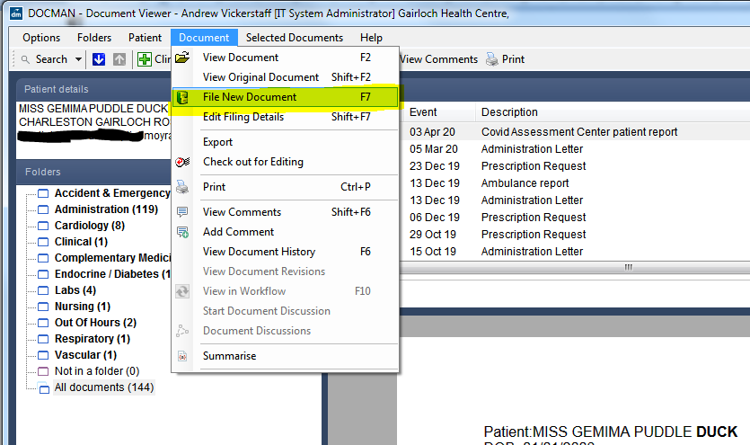
- In Docman Batch Manager choose |Capture, Capture Existing Document
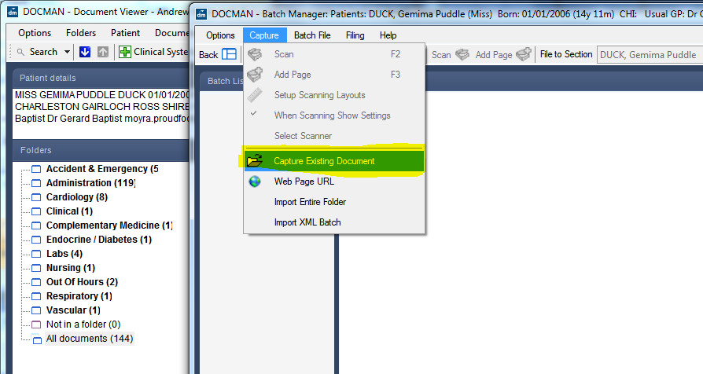
- Navigate to the desktop in Select File window and select each photograph in turn and choose to Open. The photograph(s) will appear ready to file to the patient record in the Batch Manager window.
- File each photograph in turn to the patient record and workflow as per regular Practice protocol.
[suggestion – set up a filing template called Photograph, Description Photograph, Folder Administration, File to EMIS/Vision system with Read Code 58C.. – Medical Photography]
- Once photograph(s) have been filed to the patient Docman record close Batch Manager. Return to the Docman patient record and ensure that the photograph(s) are shown as filed and live in workflow
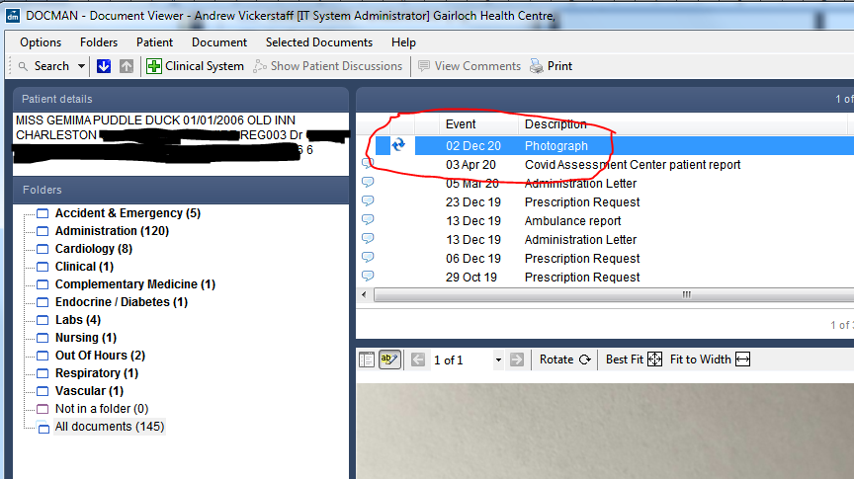
- Return to PC Desktop. Delete all photograph(s) from the desktop. Empty the Recycle Bin to ensure they are no longer available.
- Reopen Practice email client. Delete the incoming email with associated attachments.

Appendix 2 Image handling in England with EMIS.
- Patient rings in with a problem that a GP can review with a photograph
- Once in EMIS there is a link on the front screen to Accurx

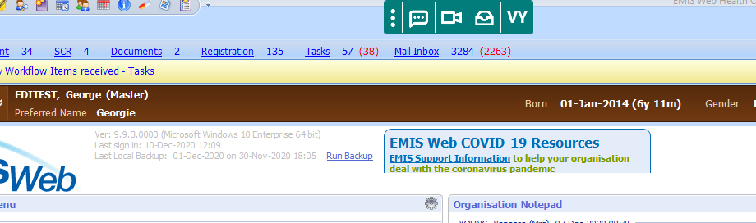

- From this link the GP can send a link to the patients mobile so that they can send a picture in

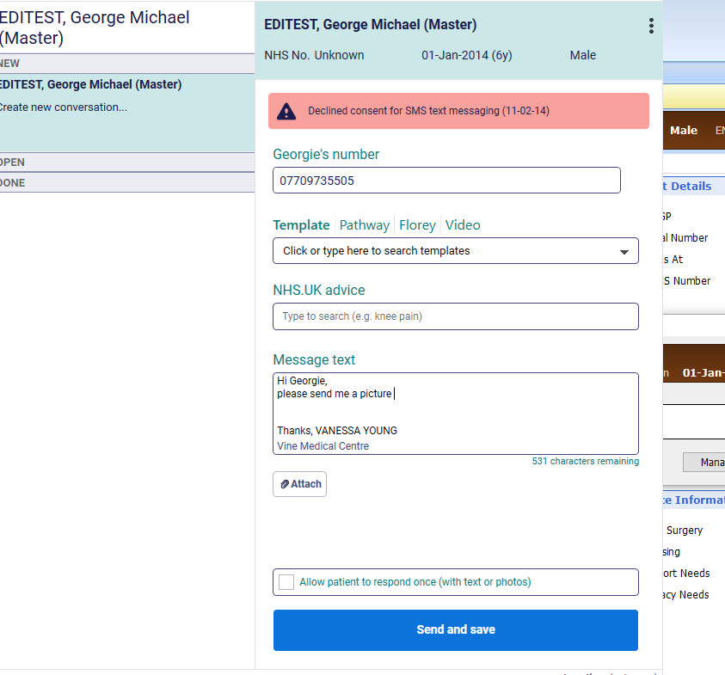
- Once the image is sent to the practice a message will appear in the icon where the envelope is and the image is saved straight into the patient records.

