Scottish Clinical Information Management in Practice
‘Back Scanning’ advice for General Practices
Additional Comments – Records Format for Back Scanned Records


SCIMP November 2019
Version 1.1 Draft
Contact: Andrew Vickerstaff andrew.vickerstaff@nhs.net

Revision History | Date of next revision: Updated as required.
Revision date | Summary of Changes
25/11/19 | Initial Draft by Andrew Vickerstaff
28/11/19 | Revisions by Chris Weatherburn

Table of Contents
Table of Contents 3
1 Introduction 4
1.1 Purpose 4
1.2 Scope and Readership 4
1.3 Document Summary 4
2 File Format Considerations 5
2.1 Table Summary of File Formats 6
3 National Folder Structure Considerations 7
3.1 Table Summary of Folder Structure 9
4 Comments 10
5 Recommendations 11
Appendix 1 Original email request for SCIMP input 12
Appendix 2 Extract from the Docman Transfer Acceptable File Types Standard document – eH4009 13
Included file types 13
Excluded file types 14
References 15

Introduction

1.1 Purpose
This document provides an update to SCIMP advice to General Practices in Scotland on best practice for ‘back-scanning’ patients’ paper records. It addresses a request received from NSS for clarification of the preferred file format for saving back scanned records and how the files should be saved within the Docman national file structure (Appendix 1).

1.2 Scope and Readership
This document is intended to be used by general practitioners, practice managers, practice IT administrators and GP IT facilitators to assist them in making appropriate business decisions based on their requirements.

1.3 Document Summary
All Scottish practices utilise the nationally supplied “PCTI Docman” scanning and document management software to scan, process and subsequently workflow incoming patient correspondence into the NHS Scotland folder structure, creating an Electronic Patient Record (EPR). This record can be electronically transferred to another practice when a patient moves practice, usually with the associated historical paper record being manually transferred via the Practitioner Services Division (PSD) courier system.

Some GP practices and/or health boards have undertaken projects to “back scan” their patient paper records to the EPR. This enables them to reduce the physical storage area dedicated to paper files and so free up valuable space to, for example, create additional consulting rooms.

This document discusses the proposal that practices and their health boards decide one of 2 options to save back scanned records: either Tagged Image File Format (TIFF) saved to one of 4 Docman folders or a single Portable Document Format (PDF).

It argues that the proposal should be separated into a consideration of file format (TIFF or PDF) and how the files should be filed within the Docman National Folder structure. The aim should be to make it as easily as is practicable for the user to find what they are looking for in the scanned record.

File Format Considerations
Docman accepts a number of valid file formats for saving documents within the EPR (Appendix 2). The majority of documents scanned from the paper original or transferred electronically to the GP practice for filing are in the TIFF format. TIFF is commonly used for exchanging raster graphics (bitmap) images between applications (Whatis.com 2019) and was developed as a standard by the Aldus Corporation in 1986, now part of Adobe. Filing a document in TIFF format within Docman supports file compression to reduce overall server storage space requirements and allows the practice to annotate parts of the document, for example by adding highlights or pre-formatted stamps.

The PDF is a very common graphic file interchange format developed by Adobe in 1992. It captures all the elements of a printed or published document in an electronic image that can be easily viewed, navigated, printed or forwarded to someone else (Whatis.com 2019). Information about the location of items on the page as well as the size and shape of page elements is all saved in a standard format which means the PDF looks the same independent of the platform Operating System or programmed used to display it. PDF files can imbed type fonts and include interactive elements such as weblinks or form sections for text entry. They can also include sufficient text information to be searchable.

Table Summary of File Formats
Table 1:
ISSUE | TIFF | PDF
Compatibility with Docman | Acceptable file format | Acceptable file format
Suitability for Docman transfer and GP2GP | Suitable for transfer | Suitable for transfer
Ability to annotate | Can be annotated within Docman programme. How useful is this for back scanned documents that may not be actively workflowed within the Practice? May be useful for highlighting important data elements and to guide summarisers. | Cannot annotate
Ability to search for text | Not searchable  Third party software such as iGPR can use OCR to scan TIFF file images. | Could be searchable if Optical Character Recognition (OCR) is used during the scanning process. Paper records need to be completely scanned and often contain elements that are either difficult to read (e.g. old ECG or fax copies) or were hand written. OCR will struggle to identify this content and so could create the opportunity to miss key elements that a text search cannot resolve.

National Folder Structure Considerations
When EPR documents are transferred between GP practices the filing metadata is carried with the document. This reduces the filing input required at the receiving practice. For this process to work then both exporting and importing practices must be using the same folder structure.

The National Folder Structure was agreed and issued in 2005 (National Standard Folder Structure for Docman Version 7, 2005). This was agreed with SCIMP and SGPC input.

As outlined in the Nationally Agreed Folder Structure, the Clinical Folder should include “Scanned clinical GP Notes”. These are also noted as separate from the Administration folder to reflect the clinical importance of what is apparently an administration document.

The current Docman Transfer Process creates a deduction report from the Vision or EMIS EPR and saves this as a single TIFF file. This file is then saved to the Clinical Folder before exporting this along with the rest of the Docman EPR. Table 2 includes the Historical Folder which should include “unclassified historical scans from previous systems or unclassified back scanning of letters”.

The original NSS request which prompted this paper stated that previous scanning programmes undertaken have tended to employ one of two formats:

- Four multi-page TIF documents in line with the Docman folder structure covering; Administration, Clinical, Historical and Labs
- A single PDF document

The National Folder Structure suggests the following inclusions for each of the proposed four folders to be used:
Table 2:
ADMINISTRATION | “Should not be used for Clinical content.”  Could include administrative paperwork
CLINICAL | “Should include scanned clinical GP notes. “  Could include handwritten pink sheets, Lloyd George cards
HISTORICAL | “Should include unclassified historical scans from previous systems or unclassified back scanning of letters.”  Certain scanned letters will be clearly linked to a particular clinical specialty so may be missed when reviewing the whole record.
LABS | “Should include all biochemistry, haematology, bacteriology and serology results. Nuclear medicine laboratory results.”  Should not include certain results such as bone scans & DEXA (Imaging), biopsy and post mortem (pathology) so as above there may be a risk of missing these elements when reviewing the whole record.

Reducing the number of Folders employed in the scanning programme will help reduce its overall cost and complexity. These considerations would seem to be independent of the choice of file format which is discussed separately above. For example, the author has experience of a paper record scan that included more than 120 separate pages, each page could potentially go into one of the above four individual Folders.

Table Summary of Folder Structure
Table 3:
ISSUE | FOUR MULTI PAGE DOCUMENTS | SINGLE DOCUMENT
Compatibility with National Folder Structure guidance | Not strictly compliant | Compatible if saved in Clinical folder. This is also consistent with the current treatment of the GP System Record created as part of patient deduction in Docman transfer.
Ease of finding elements in large paper record | Easier to find than with a single multi page image but may lead to confusion if assumptions are made about consistent use of the National Folder Structure | Use of OCR will help to facilitate electronic text based search of content. However, not all text will be identifiable using OCR e.g. handwriting which may increase the risk that content is overlooked.

Comments
The SCIMP WG had constructive debate about this matter and didn’t reach a clear consensus.
Agreement was reached that irrespective of the file type we strongly recommend that they are searchable. Therefore we promote the use of OCR, which can be possible with either type of file as third party applications can be used to perform this task.
Thought should also be made about what is occurring in other nations. PRSB have recently closed a survey, which has not yet been reported that aimed to obtain people’s views on digitising general practice historic records. When published this report could have useful recommendations to consider.

Recommendations
- The proposed file format should be considered separately from the Folder structure to be employed
- The most important consideration is how easily a clinician or administrator in the GP practice can find what they are looking for in the back scanned record. The use of OCR with PDF file format should facilitate this but cannot always be a replacement for a manual scan of the full record
- Diverting from the National Folder Structure guidelines may increase the risk that content may be missed when reviewing the whole patient record

Appendix 1 Original email request for SCIMP input
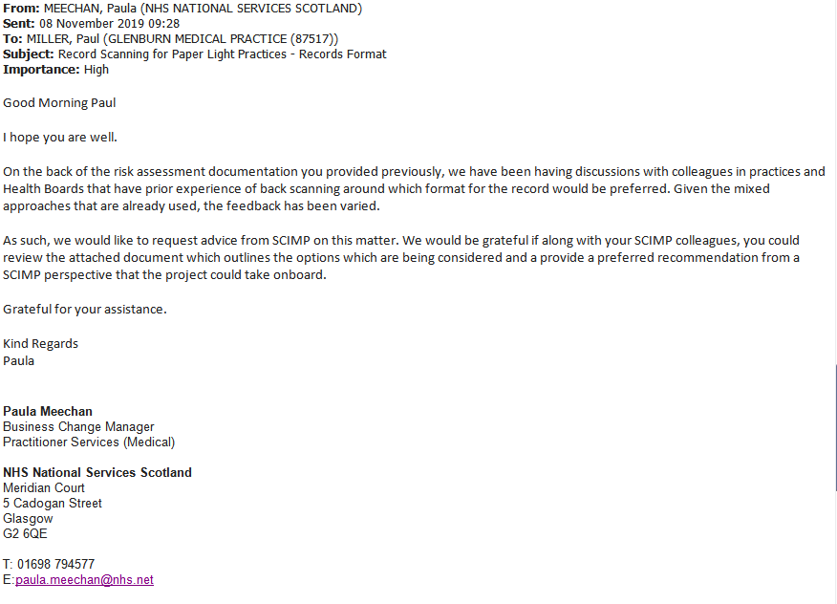

Attached Document

Appendix 2 Extract from the Docman Transfer Acceptable File Types Standard document – eH4009

Included file types
The file extensions included below are known acceptable file types for Docman.
Extension | Description | Acceptable | Comment
Rtf | Rich Text | Yes
Jpg/Jpeg | JPEG Image | Yes
Bmp | Bitmap Image | Yes
Txt | Plain Text | Yes
Csv | Plain Text | Yes
Pdf | Portable Document Format | Yes
Tif, Tiff | TIFF (Tagged Image File Format) | Yes (version 6 only) | No way to enforce version check
Mdi | Microsoft Office Document Imaging | Yes | Preferably practices would use TIFF
Doc | Microsoft Office Word 97 or above | Yes (no macros, no mail merge) | No way to enforce macro/mail merge checking
Xls | Microsoft Office Excel 97 or above | Yes (no macros) | No way to enforce macro checking
Htm, html | Web Pages | Yes (no external links/references) | No way to enforce checking of external links/references
Txt, Htm, Msg | Email | Yes (plain text/web pages preferred) | Msg is being coped with places dependency on Microsoft Outlook being installed for all readers
Xps | Microsoft Electronic Document format | Pdf or Tiff format accepted as alternative | Xps
Table 2: Initial proposed acceptable file types
Several of these file types include additional notes and guidelines for best practice – enforcement of these guidelines is outside the ability of the currently proposed standard.

Excluded file types
Any file type not specified above would block export of a patient medical record. Examples include, but are not limited to:
Extension | Description | Comment
Pub | Microsoft Publisher format | Dependent on content, Pdf/Tif/Html suggested as acceptable alternatives
Mht | Web archive | Html format accepted as alternative
Dot | Microsoft Word Document template | Doc format accepted as alternative
Exe | Windows executable file | File contains no clinical content, should not be included
Dll | Windows library file | File contains no clinical content, should not be included
Lnk | Windows shortcut file | Shortcut file should be replaced by target
Shs | Microsoft Office document scrap file | Scrap file should be replaced by MS Office file saved in appropriate format (Doc or Xls)
Url/Http/Ftp | Internet/website address | Dependent on content, Html format accepted as alternative. This format is included in the SCIMP/DfH guidelines.
Zip | Compressed file | Content(s) of compressed archive should be filed individually in patient record
Qrp | QuickReport (GPASS specific) | Pdf or Tiff format accepted as alternative
Avi/Mpg/Mpeg | Movie files | This format is included in the SCIMP/DfH guidelines.
 | Proprietary | This format is included in the SCIMP/DfH guidelines.
DICOM | DICOM is a container format that also includes the potential for moving images | This format is included in the SCIMP/DfH guidelines.

References

MR002 Docman Transfer Project Docman Transfer Process – GP Guidelines
https://nhsnss.org/services/practitioner/medical/medical-records/records-transfer/

National Standard Folder Structure for Docman Version 7
https://www.scimp.scot.nhs.uk/wp-content/uploads/documents/Procedures-DocManDocumentFoldersv2.3_2011update.pdf

Professional Records Standards Body, Digitising Historic GP Records
https://theprsb.org/projects-2/lloydgeorgerecords/

SCIMP Summarising Medical Records
http://www.scimp.scot.nhs.uk/guidance/summarising-medical-records/

Scottish Government Records Management: NHS Code Of Practice (Scotland) Version 2.1 January 2012
http://www.scotland.gov.uk/Publications/2012/01/10143104/0

Whatis.com definition TIFF (Tag Image File Format)
https://whatis.techtarget.com/definition/TIFF-Tag-Image-File-Format

Whatis.com definition PDF (Portable Document Format)
https://whatis.techtarget.com/definition/Portable-Document-Format-PDF

