SCIMP – GP Quick Guide to Immunisation changes for 2015-16
Version 1.1 September 2015
This document summarises the changes to the immunisation schedules that will impact on General Practices for 2015-16, particularly in relation to IT issues. It does not cover details of the full childhood immunisation schedule or full details of the annual flu immunisation programme. Links to relevant documents are given for further advice. This document may be subject to change if further information becomes available.

Click on Link below to go to relevant page in document.
Meningitis B
Meningitis ACWY
Influenza
Herpes Zoster
Pertussis

Meningitis B
Target | From 1st September 2015, to all babies born on or after 1.7.15 . Catch up for babies born between 1.5.15 – 30.6.15 if attending other routine 3 and 4 month immunisations. Those born before 1.5.15 are NOT eligible for vaccination programme
Who by | HV / Primary Care
When | With routine vaccinations, Priming doses at 2 and 4 months plus a booster dose at 12-13 months.  Catch up for babies born on or after 1.5.15 when they attend for other routine immunisations at 3 and 4 months. If third routine primary immunisation appointment due => 1 September then follow this schedule: 4 months and 12-13 months (1+1). If second routine primary immunisation appointment due => 1 September then follow this schedule: 3, 4 and 12-13 months (2+1)
Call up | The Scottish Immunisation Recall System (SIRS) will provide call & recall for Men B vaccination for children born on or after 7/7/15. For children born from 1/5/15 to 6/7/15, lists of eligible children (based on birth date) will be sent to treatment centres by child health/SIRS departments, so that Men B can be offered at children’s 2nd and/or 3rd primary vaccination appointments.
Cautions | See Green book for cautions / allergy information. To be given im into left thigh ideally on it’s own, if not possible at least 2.5cm from other vaccine. (if Hx bleeding disorder then give s/c). Fever a common side-effect so 3 doses of paracetamol advised after vaccination at 2 and 4 months.
Coding  (software systems will incorporate in usual way) | 65710 First meningitis B vaccination  65711 Second meningitis B vaccination  65712 Third meningitis B vaccination  65715 First meningitis B vaccination given by other healthcare provider  65716 Second meningitis B vaccination given by other healthcare provider  65717 Third meningitis B vaccination given by other healthcare provider
8IHC. Meningitis B vaccination declined
8I23P Meningitis B vaccination contraindicated
TJJy0 Adverse reaction to meningococcal vaccine
Vaccines | Bexsero. An inactivated multicomponent vaccine. Licensed from 2months of age. Order via usual HB system. Paracetamol supplied by GP10a stock order forms
Green book | https://www.gov.uk/government/uploads/system/uploads/attachment_data/file/448875/2904185_Green_Book_Chapter_22_v3_0W_July2015.PDF
CMO letter | http://www.sehd.scot.nhs.uk/cmo/CMO(2015)11.pdf
Useful links | Patient Information:- www.immunisationscotland.org.uk/menb.  Training for health professionals:- http://www.nes.scot.nhs.uk/education-and-training/by-theme-initiative/public-health/health-protection/immunisation/meningococcal-b-disease-for-infants-aged-from-two-months.aspx  JCVI:- https://www.gov.uk/government/publications/meningococcal-b-vaccine-jcvi-position-statement
Meningitis ACWY – University entrants age <25 + Catch-up for 14-18yr olds
Target | - GP - First time university entrants age <25 (who haven’t received Men ACWY vaccine in school). Ideally 2 weeks before the start of term. No later than 31.3.16. (Replaces previous Men C vaccine)  - From 1.8.15 - One year catch-up of 14 – 18yr olds (including routine S3 cohort)  GP - 1.8.15 to 31.3.16. 18 yr olds (dob 2.8.96 – 28.2.97) plus all 15-18 yr olds (dob 1.3.97 – 29.2.2000) who have left school.  GP - 1.1.16 to 31.3.16 All 16-17yr old Christmas 2015 school leavers (dob 1.3.99 – 29.2.2000)  HB (in schools) 1.1.16 – 31.3.16 Catch up for S4, S5 and S6 pupils + routine cohort in S3.  Children who have previously received Men C vaccination should still be offered Men ACWY vaccination. Allow minimum of 4 weeks between.
Who by | GP / nhs Board (in schools)
When | From 1.8.15. For first year University entrants ideally given at least 2 weeks before starting university. Where students are not vaccinated before leaving for university they can register with a new GP Practice and arrange to get the vaccine there as soon as possible, ideally in freshers’ week.
Call up | Students will be advised to request immunisation through UCAS, in their August eNewsletter. No requirement for GP system recalls. . Academic year 2014-15 S6, S5 age cohorts will be advised by a central letter funded by the Scottish Government in Aug/Sept 2015. Likely to be a further letter for the 2014-15 S4 age cohort in Jan 2016..
Cautions | See Green book chapter for cautions / allergy information
Coding | 657J0 First meningitis ACW & Y vaccination  657J4 Meningitis ACW & Y vaccination given by other healthcare provider
657J5 Meningitis ACW & Y vaccination declined
TJJy0 Adverse reaction to meningococcal vaccine
8I23Q Meningitis ACW & Y vaccination contraindicated
Vaccines | Nimenrix and Menveo. Single dose im into upper arm or thigh. Can be safely given with other adolescent vaccines.
Green book | https://www.gov.uk/government/uploads/system/uploads/attachment_data/file/448875/2904185_Green_Book_Chapter_22_v3_0W_July2015.PDF
CMO letter | 20.8.15, Amendments to previous CMO letter http://www.sehd.scot.nhs.uk/cmo/CMO(2015)15.pdf  http://www.sehd.scot.nhs.uk/cmo/CMO(2015)10.pdf
Useful links | Patient Information:- http://www.immunisationscotland.org.uk/vaccines-and-diseases/menw.aspx  Training for health professionals:- http://www.nes.scot.nhs.uk/education-and-training/by-theme-initiative/public-health/health-protection/immunisation/meningococcal-acwy-immunisation-programme-for-adolescents.aspx
Influenza
Target | 65 years and over
 | At risk groups. Children aged 2 to <9 years in at-risk group and not received any flu vaccine before to receive 2 doses given 4 weeks apart. Changes to the ‘Primis’ risk group code specifications to include morbid obesity (BMI=>40) for the first time.
 | 2 to 5 year olds (born 2/9/09 to 1/09/13) who are not yet attending school
 | All Primary school children (NHS Boards responsibility to arrange these). Children can make appointment with GP for vaccination if have missed school session (change from last year).
Who by | 65+, at risk (including secondary school pupils) and 2-5 yr. olds (not yet in school) – Primary Care. School programme for primary school children. Primary care for those at primary school who miss school session or require a second dose
When | 1.10.15 to 31.3.16
Call up | Primary Care to call 65+, at risk groups and 2 - 5 yr. olds not yet in school (will receive list from SIRS for 2-5yr olds). Also may need to recall primary school pupils if in at risk group so requiring second immunisation. Not required to call up other school age children who have missed vaccination through school session.
Vaccine | For children - Fluenz Tetra – a live attenuated nasal flu vaccine. Divided dose (0.1ml) to be given into both nostrils. If Fluenz contraindicated can be offered inactivated injectable vaccine (see green book or CMO letter for most suitable for age).
Cautions | See green book.
Recommended Coding  (other codes are available – see Primis list on SCIMP website)  (software systems will incorporate in usual way) | 65ED% Seasonal influenza vaccination  65E20 Seasonal influenza vaccination given by other healthcare provider  65E21 First intranasal seasonal influenza vaccination given by other healthcare provider  65E22 Second intranasal seasonal influenza vaccination given by other healthcare provider  65E24 First intramuscular seasonal influenza vaccination given by other healthcare provider  65E23 Second intramuscular seasonal influenza vaccination given by other healthcare provider  65ED0 Seasonal influenza vaccination given by pharmacist  65ED1 Administration of first intranasal seasonal influenza vaccination  65ED3 Administration of second intranasal seasonal influenza vaccination  65ED2 Seasonal influenza vaccination given while hospital inpatient
8I2F0 Seasonal influenza vaccination contraindicated
68NE0 No consent for seasonal influenza vaccination
9OX51 Seasonal influenza vaccination declined
9OX54 First intranasal seasonal influenza vaccination declined
9OX56 Second intranasal seasonal influenza vaccination declined
14LJ. H/O: influenza vaccine allergy
U60K4 [X]Influenza vaccine causing adverse effects in therapeutic use
ZV14F [V]Personal history of influenza vaccine allergy
Other considerations | Primary school children in ‘at risk’ group will be offered one immunisation at school.  One dose required for healthy children. Two doses for at risk children under 9 years who can have Fluenz Tetra, and who are receiving influenza vaccine for the first time. Also injectable inactivated vaccine requires two doses for any (healthy or at risk) children under 9 receiving vaccine for the first time who cannot receive the intra-nasal vaccine.  Fluenz Tetra can be given at the same time as other live vaccine (e.g. MMR, BCG)  4 weeks between 1st and 2nd dose of Fluenz Tetra if required.  Fluenz Tetra should not be given to children age <2 years or >=18 years. See Green book for other contra-indications (advice for egg allergy changed and can now be given unless severe life threatening allergy which has previously required intensive care )
Monitoring | HPS will monitor uptake via aggregate data extractions from GP practice systems.  Practices will be asked by PSD to submit denominator figures for:-  1) <65 years at risk (which should include those 2-5yrs who have a “clinical” at risk status )  2) Children in 2-5yrs age range
Green book link | Updated May 2015 (flowchart for schedule removed in 2015):- https://www.gov.uk/government/uploads/system/uploads/attachment_data/file/427809/Green_Book_Chapter_19_v9_0_May_2015_.PDF  Note that a patch to the green book has been published (28.8.15) making amendments to the previous publication:-  https://www.gov.uk/government/uploads/system/uploads/attachment_data/file/456569/Green_Book_Chapter_19_Patch_v10_0.pdf
CMO letters | 10/7/15 :- http://www.sehd.scot.nhs.uk/cmo/CMO(2015)12.pdf  10/7/15 (Children) :- http://www.sehd.scot.nhs.uk/cmo/CMO(2015)13.pdf

Flowchart for Children and Types of vaccine (Produced by HPS / NES 2015-16)
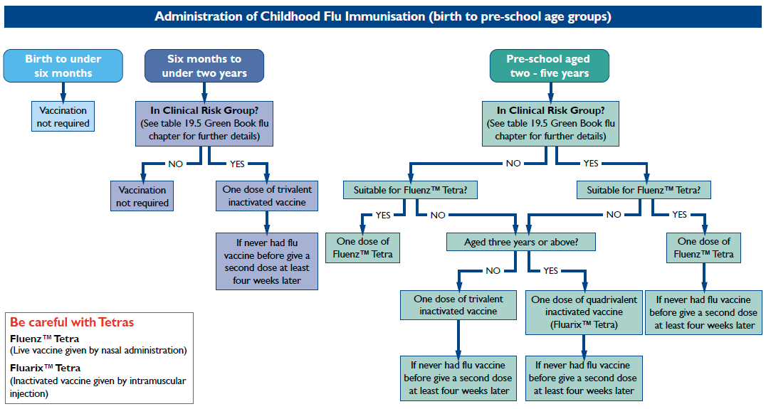

Herpes Zoster
Target | Age 70 (on 1.9.15, born between 2.9.44 and 1.9.45) plus catch up for age 78 (on 1.9.15, born between 2.9.36 and 1.9.37). For 2015 – 16 can also immunise those who were eligible since 1.9.13 (now age 71, 72, or 79) but missed immunisation (but not if now aged =>80 (reduced efficacy with age).
Who by | Primary Care
When | 1.9.15 to 31.8.16. Can call up from 1.8.15 if wish to use up existing stock.
Advertising | Call up by GP practice
Call up | GPs have flexibility to call and vaccinate individually or in batches throughout the year. Can be with Flu vaccination.
Cautions | See Green book chapter for full details.  Recommended interval with MMR and other travel live attenuated vaccines eg. Yellow fever, is 4 weeks. There are no other restrictions between Zostavax and other live vaccines. Can be given jointly with flu and pneumococcal vaccine for those who are eligible.  See Green Book details for immunosuppression and therapy contraindication advice.  Individuals who have shingles or Post Herpetic Neuralgia should wait until symptoms have ceased before being considered for shingles immunisation and for 48 hours after finishing any anti-viral treatment.
Coding | 65FY. Herpes zoster vaccination  65FY0 Herpes zoster vaccination given by other health care provider
8I2r. Herpes zoster vaccination contraindicated
8IEl. Herpes zoster vaccination declined
9Nig. Did not attend herpes zoster vaccination
68Nv. No consent for herpes zoster vaccination
U60K6 [X]Herpes zoster vaccine causing adverse effects in therapeutic use
Vaccines | Zostavax (live attenuated vaccine). Note is not the same as Varicella (chickenpox) vaccine as contains a higher dose. 1 dose (0.65ml) s/c (preferably deltoid region). Should not be given im or iv. If given with other vaccines ensure separate sites (at least 2.5cm apart if in same limb)  Supplies should be obtained from local NHS Board vaccine-holding centres. Details of these are available from National Procurement (Tel. 0131 275 7587)
Green book | https://www.gov.uk/government/uploads/system/uploads/attachment_data/file/448815/2904130_Green_Book_Chapter_28a_v1_0_0W_July2015.PDF
CMO letter | 10/07/15 - http://www.sehd.scot.nhs.uk/cmo/CMO(2015)14.pdf
Useful links | HPS site - guides for eligibility and screening for contraindications. - http://www.hps.scot.nhs.uk/immvax/shinglesvaccine.aspx  DOB eligibility calculator (update due Sept 2015) www.immunisationscotland.org.uk/shingles

Pertussis
For pregnant women.
Target | Pregnant women,
Who by | Primary care
When | From 28 weeks of pregnancy onwards. Ideally 28-38 weeks of pregnancy. Can be offered after this and to mother post-natally up to time of childs first immunisations. Should be given again in a subsequent pregnancy.
Advertising | Leaflets and posters distributed to GP Practices, Maternity Units,  Pharmacies and Community Centres. See first CMO letter for link to request more.
Call up | Midwives to advise / counsel women and by practice
Cautions | See green book
Coding | As well as coding immunisations need to consider coding of pregnancy so can determine denominator population. Suggested code - 621.. (Patient currently pregnant).  655.. Pertussis vaccination  655Z. Pertussis vaccination NOS  ZV036 [V]Pertussis vaccination
68NQ. Pertussis vaccine contraindic.
8IEc. Pertussis vaccination in pregnancy declined
9mK.. Pertussis vaccination in pregnancy invitation
9Nif. Did not attend pertussis vaccination in pregnancy
TJJ6. Adverse reaction to pertussis vaccine, including combinations with a pertussis component
 | Health Boards will require details of vaccinations
Vaccines | Repevax replaced by Boostrix-IPV in 2014 through national procurement changes.
Other considerations | Can be given at same time as flu vaccination (also recommended in pregnancy). Can be given at the same time as anti-D. If recently had Td/IPV, leave at least a month before giving Repevax
Green book | https://www.gov.uk/government/uploads/system/uploads/attachment_data/file/424448/Green_Book_Chapter_24_Pertussis_v2_0_April_2015.pdf
CMO letter | Programme extended 25.4.13 - http://www.sehd.scot.nhs.uk/cmo/CMO(2013)03.pdf

