SCIMPSIG Open Platforms in Scotland Stirling 19.5.18
Chatham House rule discussions de-identified by default to enable open exchange of views.
Contributors introduced themselves and the following topics were discussed:

eHealth setting – UK and general
- collective experience decades long but many lessons not yet learned e.g. recent UK eHealth Week
- Apperta document identifies many apps as megasuites with their data in silos
- from megasuite supplier POV, they “won’t and can’t” change their products
- working to define the platform from an architectural POV.
1. Clinical -->> health and care
2. Which standards should be on the Platform?
3. What is Open and what is Platform?
- Health Data has been Privatised by Stealth: is it an international consumer scandal?
- transformation must create a butterfly not a giant caterpillar
- focus on data migration - the Lowest Common Denominator of data transformation.
- Putting Data In is even greater issue that Getting Data Out
- can GP systems still be the main source of truth? – appears beyond current GP capacity
- InterOpen: multi-agency collaboration in UK, esp. now on FHIR profiles
- OpenEHR foundation manages the international collaboration
- cloud hosting of small apps - the future?
- GP system market is broken, so change them by stealth on topics where users have:
- hi demand, and
- hi frustration with supplier failure e.g. Respect CDS, nurse MH assessments.
But some suppliers are now component-ising their products
- Guerrilla informatics!
- longer contract periods, but we need flexibility to support mandated new functionality
- wide range of clinical specialties worked with e.g. gap analyses, many vendor relationships
- integrating care a big driver, as patients don’t work in silos
- in other sectors, tech is not the driver, process and people are: it’s socio-technical.
- GPASS’ API was the first – but was it open? – technologically yes, but did cost.

NHS Scotland setting:
- new strategy makes explicit commitment to “Digital Platform” – intent is ‘Open’
- will use CDS program using Cambio s/w that uses OpenEHR
- single national drug formulary an early instance of Knowledge Management
- 2018 Digital Health and Care plan uses Knowledge Plan
- ISD and Public Health Intelligence as drivers of secondary uses of health data
- Clinical GP practice creates daily drivers to improve primary uses for Direct Care
- NHS Scotland tasks incl. safety issues > CSO training by NHS Digital
- “Reasonable Adjustments” program in NHSE: this dataset – of a citizen’s specific conditions requiring RA by public bodies - to persist on Spine, can be consumed as a microservice by multiple public bodies
- GP IT service, SPIRE and ECS service challenges: requires bridging of user RFCs to suppliers by contracts. “Shared objectives” are usually partial i.e. not general nor fully shared.
- users need to collaborate to manage their RFCs
- advice is often what to avoid – learning from “failure”
- learn from GPASS – socio-political failure to manage the IT tech, but had “Open” credentials
e.g. has Greenhalgh’s NASSS framework been applied?
- political drivers of businesses incompatible with collaborative work, e.g. a unified user base.
LAs are politically driven re social care, NHS is less so.
regional and national drivers also inconsistent.
- personal leadership per Scandic nations, Singapore e.g. large orgs connected to small
- international issues: Scotland is not exceptional

Presentation
Confidentiality agenda has become a driver for silo-ing of systems – though should it be?
Sharing of data must be of only relevant data, and supported by GDPR.
Federation of systems a good design principle – but hard to implement.

Definitions of Terms:
“Open” can mean IPL / licensing, OR can mean tech to Open Standards
“Open” API currently seldom conform to an Open Standard
Platform: - a specific interface that is publicly exposed, AND
- a set of tech specs forming a coherent definition of this interface
API: s/w interface showing:- computational view, informational view, protocol spec.
so specifies the language and order in which components communicate
Bus: transfers data between components
Enterprise Service Bus is a key component of any Platform: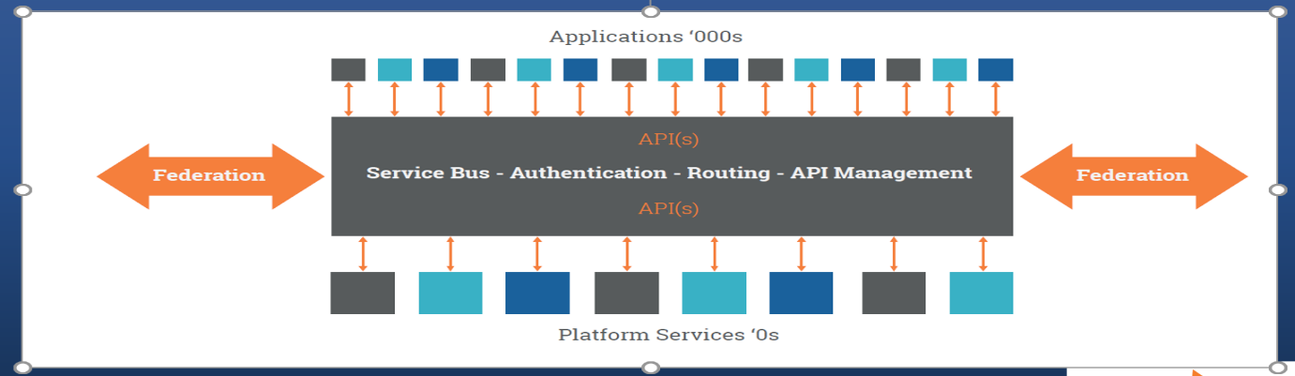
Interoperability: Tech, Semantic and Process: see John Meredith take on Benson/Grieve diagram:
- 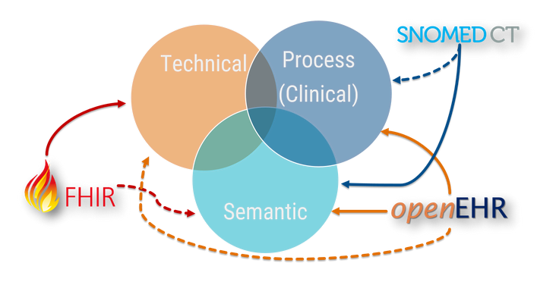”

The Product - discussion
ISO, BSI, TUV etc are commercial orgs, so their “Standards” are not necessarily IT standards
NHSE are using ISO Standards for Clinical Safety standards that they mandate.
Transactional pricing not in UK yet, it’s all licensing

What are Good Records?
“It hasn’t been done if it hasn’t been written down” – does this traditional aphorism still hold?
Not if interpreted to mean indefinite duty to record everything
- but write once / read many should apply.
Does IT enable the safer recording of negation?
e.g. by use of finite lists that scope clinical care and safely manage negatives.
“Current paradigm of unstructured data in disjointed silos obstructs service re-design.”
Clinical Information Models vary unaccountably between suppliers – because apps were developed independently. Can we also open out the CIM to be vendor-neutral – into The Commons?
The CIM and the database remain proprietary, but 3rd party apps add in via API, most using FHIR.
The top conceptual level of the classic OSI network stack, which is level 7 (so Health Level 7, known as HL7) includes the apps, but does not address the informatics or structure of the data.
Do we need a “level 8” to expose that the Data exists, and can persist, independently of the Apps?
We need Virtual Environments to model changes in service delivery, and the scope of clinical content.

The Marketplace - discussion
Procurement issues e.g. which functions should be mandatory, supplier engagement, discussed.
US 21 Century Cures Act 2016: introduces new federal offence of Information Blocking:
- “inter-operability” = exchange “without special effort on the part of the user”
- complaints generated by patients who have suffered harm
- managed on a US-wide basis, to clarify each case and unite the user base around class actions
- vendors can be found to have knowingly failed to implement commonly available sharing technologies AND those are better than their own implementation.
Do citizens need a similar driver here? – discussed. Risks of unpredictable legal outcomes.
Platform for Scotland:
Should this be based on Apperta paper, or on the Gartner diagram?
This appears different, but we consider this is intended to detail and map to Apperta blueprint in all significant topics.
“Apps are transient but Data persists” – so de-couple Apps from vendor-neutral models and the Vendor- and Technology - Neutral data repositories.
OpenEHR features: CDR is Vendor neutral / Tech neutral / No code configuration
Clinical community to contribute: Tooling / Collaboration / Semantics / Governance / Demonstrators
Seed-corn nature of program: should we approach current vendors at each contract-renewal, or avoid direct competition?

Is there a list of all the systems in NHS Scotland with their contract end-dates? – discussed.
Contract renewals use contract duration to guarantee vendor lock-in, as seen in mobile phone or broadband packages.

Change management issues:
- set a future date for Open Standards-compatibility e.g. 3 yrs officially (to allow for slippage)
- technology should not be specified, as there are alternatives.
We note that OpenEHR is mature with up to 20yrs development of clinical content, many installations including persistent CDRs, and a long history of clinical support (e.g. per CKM)
- require that new components should use Open Platform.
FHIR - there are to date 2 vendors with FHIR-based EPRs.
The industry direction of travel is currently to FHIR messaging as set of microservices additional to the megasuite. We can support this as complementary to other EPR components using OpenEHR.
e.g. Salford use Allscripts, and have added an OpenEHR CDR.
The rights of GDPR for citizens to withdraw their own data underpins the contract itself also being open to bulk withdrawal.

Conclusions
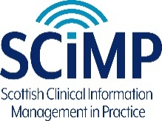
See Implementing Open Platforms in Scotland: A Framework in 4 levels
Do we need a Chief Information Officer for Scotland?
And/or an eHealth&Care CIO for NHSS / NSS / ISD / PHI?
We also assert that:
- Open Platforms, as in Apperta document and detailed in Gartner strategy, are fit for purpose, and good enough to adopt NOW.
- a nationwide adoption of Personal Health Records depends on the nationwide adoption of Open Platforms in NHS systems
- clinical user functionality is critical to NHSS performance incl. staff recruitment/retention
- GDPR supports citizens to reclaim their data from IT systems, Open Platform enables this
- Security of NHSS depends on joining this international collaboration

Reasons for change to Open Platform (Risks of inaction)
- Health Networking liable to Combinatorial Explosion of nodes
- Cost savings not till medium term - is infrastructural so need for financing on long-term ROI e.g. Estonia Govt. program: mandation does not work, so paid for the upgrade from legacy systems
- Citizen or IG policies e.g. GDPR portability rights, option to support by analogue of US C21 law
- Includes support for XDS, a mature effective architectural solution for document-level data
- Open Platform is an international enterprise, and Scotland would be joining this for safety and assurance

Sample Elevator Speech* for Progressive Health Informatics:
- Wherever you go to get healthcare, the way your data is stored is often different from where you went before.
- This is because each healthcare location has several types of IT system, and
each system records your health data in its own way.
- If you want to manage your own data, or to get healthcare elsewhere, access to your data has to be bought from the previous system’s supplier.
- It’s as if it doesn’t really belong to the person, but to the IT suppliers who control access to it
OR
- It’s as if our health data has been privatised without our consent
- So if we all need personal health data to go with the person,
we need to re-use it free of restrictions, and free of charge.
- Open Platform design can fix this, and upgrading our IT systems to this has been estimated
to save 11% of total NHS costs.

* An elevator pitch, elevator speech, or elevator statement is a short description of an idea, product, company, or oneself that explains the concept in a way such that any listener can understand it in a short period of time.
From https://en.wikipedia.org/wiki/Elevator_pitch

