SCIMP – GP Quick Guide to Immunisation changes for 2014-15
Version 1.1 September 2014
This document summarises the changes to the immunisation schedules that will impact on General Practices for 2014-15, particularly in relation to IT issues. It does not cover details of the full childhood immunisation schedule or full details of the annual flu immunisation programme. Links to relevant documents are given for further advice. This document may be subject to change if further information becomes available.

Click on Link below to go to relevant page in document.

Meningitis C
Influenza
Herpes Zoster
Pertussis

Meningitis C – Catch-up. University entrants age <25
Target | First time university entrants age <25 - 1 dose MenC (not required if had booster above age of 10)
Who by | GP
When | From 1.8.14. Ideally given at least 2 weeks before starting university. Where students are not vaccinated before leaving for university they can register with a new GP Practice and arrange to get the vaccine there as soon as possible, ideally in freshers’ week and no later than 31 October 2014. If an individual seeks vaccination later than 31 October 2014 then GP Practices should apply clinical judgement to assess the benefits of the vaccine at that point. Likely to stop in 2017
Call up | Students will be advised to request immunisation through UCAS, in their August eNewsletter. No requirement for GP system recalls
Cautions | See Green book chapter for cautions / allergy information
Coding  (software systems will incorporate in usual way) | 657I. Single meningitis C vaccination  657S. Booster meningitis C vaccination  657S0 Booster meningitis C vaccination given by other healthcare provider
Coding  (software systems will incorporate in usual way) | 68Nh. Meningitis C immunisation refused  68Nh0 Booster meningitis C vaccination declined  68Nf. No consent for meningitis C immunisation  TJJy0 Adverse reaction to meningococcal vaccine
Vaccines | Menjugate Kit (Norvartis Vaccines)  Neis Vac-C (Baxter Healthcare)  Meningitec (Pfizer) - (not for use in infants under 1 year)
Green book | https://www.gov.uk/government/publications/meningococcal-the-green-book-chapter-22
CMO letter | 7.5.13:- http://www.sehd.scot.nhs.uk/cmo/CMO(2013)06.pdf  17.6.14:- http://www.sehd.scot.nhs.uk/cmo/CMO(2014)11.pdf
Useful links | Patient Information:- http://www.immunisationscotland.org.uk/  Training for health professionals:- http://www.nes.scot.nhs.uk/education-and-training/by-theme-initiative/public-health/health-protection/immunisation/meningitis-c.aspx

Influenza
Target | 65 and over
Target | At risk groups (different dose schedule for <9yr old receiving vac for first time). Children aged 2 to <9 in at-risk group and not received any flu vaccine before to receive 2 doses given 4 weeks apart.  Changes to the ‘Primis’ risk group code specifications such that AF, Severe Learning Disability and Splenic Dysfunction now included. The latter includes conditions such as Coeliac Disease, Thalassaemia and Sickle cell disease.
Target | 2 to 5 year olds (born 2/9/08 to 1/09/12) who are not yet attending school
Target | All Primary school children (NHS Boards responsibility to arrange these)
Who by | 65+, at risk and 2-5 yr. olds – Primary Care. Arrangements for catch up of primary school children (including those in 'at risk' groups) if missed at school is by agreement between local HB and LMC. Secondary school children in 'at risk' groups remain the responsibility of General Practice.
When | 1.10.14 to 31.3.15
Call up | Primary Care to call 65+, at risk groups and 2 - 5 yr. olds (will receive list from SIRS for 2-5yr olds). Also may need to recall primary school pupils if in at risk group so requiring second immunisation.
Vaccine | For children - Fluenz Tetra – a live attenuated nasal flu vaccine. Divided dose (0.1ml) to be given into both nostrils
Cautions | See green book.
Recommended Coding  (other codes are available – see Primis list on SCIMP website)  (software systems will incorporate in usual way) | 65ED% Seasonal influenza vaccination  65E20 Seasonal influenza vaccination given by other healthcare provider  65E21 First intranasal seasonal influenza vaccination given by other healthcare provider  65E22 Second intranasal seasonal influenza vaccination given by other healthcare provider  65ED0 Seasonal influenza vaccination given by pharmacist  65ED1 Administration of first intranasal seasonal influenza vaccination  65ED2 Seasonal influenza vaccination given while hospital inpatient  65ED3 Administration of second intranasal seasonal influenza vaccination
8I2F0 Seasonal influenza vaccination contraindicated
8I6D0 Seasonal influenza vaccination not indicated
68NE0 No consent for seasonal influenza vaccination
9OX51 Seasonal influenza vaccination declined
9OX54 First intranasal seasonal influenza vaccination declined
9OX56 Second intranasal seasonal influenza vaccination declined
14LJ. H/O: influenza vaccine allergy
U60K4 [X]Influenza vaccine causing adverse effects in therapeutic use
ZV14F [V]Personal history of influenza vaccine allergy

Other considerations | Primary school children in ‘at risk’ group will also be offered immunisation at school. They will only be offered one dose in school. Arrangements for children in 'at risk' group who miss the school vaccination or need a booster dose, will be organised by the local Health Board. This may involve locally negotiated agreements with LMC.  One dose required for healthy children. Two doses for at risk children under 9 years who can have Fluenz Tetra, and who are receiving influenza vaccine for the first time. Also injectable inactivated vaccine requires two doses for any (healthy or at risk) children under 9 receiving vaccine for the first time who cannot receive the intra-nasal vaccine.  Fluenz Tetra can be given at the same time as other live vaccine (e.g. MMR, BCG)  4 weeks between 1st and 2nd dose of Fluenz Tetra if required.  Fluenx Tetra should not be given to children age <2 or >=18, or children if have egg allergy, symptomatic or severe asthma, or if severely immunocompromised.
Monitoring | HPS will monitor uptake via aggregate data extractions from GP practice systems.  Practices will by PSD to submit denominator figures for:-  1) <65 at risk (which should include those 2-5yrs who have a “clinical” at risk status )  2) Children in 2-5yrs age range
Green book link | Updated August 2014 https://www.gov.uk/government/publications/influenza-the-green-book-chapter-19
CMO letter | 18.6.14:- http://www.sehd.scot.nhs.uk/cmo/CMO(2014)12.pdf  18.6.14 (Children) :- http://www.sehd.scot.nhs.uk/cmo/CMO(2014)13.pdf
The future | JVCI has recommended that eventually vaccination programme will be extended to all 2-16 yr olds. 2014 sees extension of the initial implementation started in 2013.

Chart reproduced from Green Book 2014-15
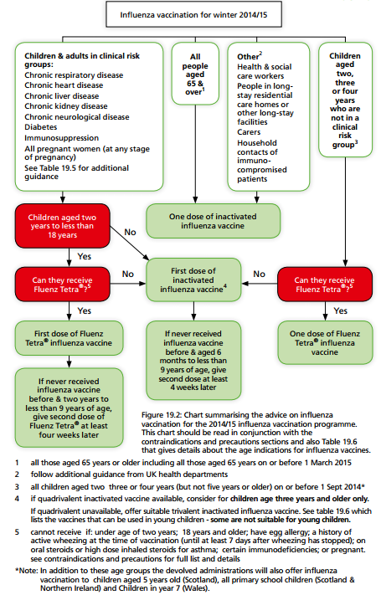
Flowchart for Children and Types of vaccine (Produced by HPS / NES 2014-15)

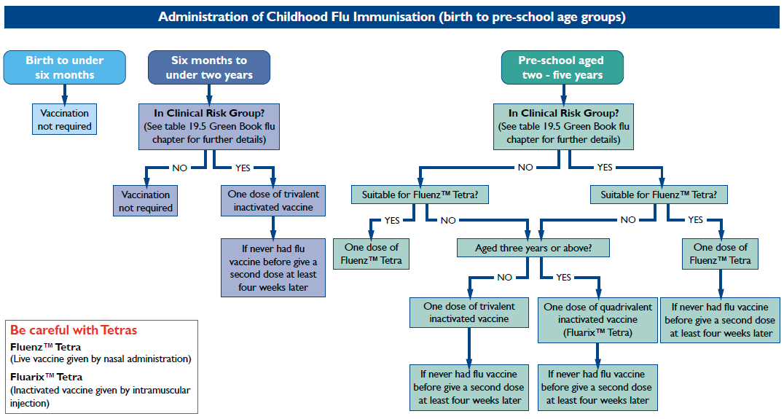

Herpes Zoster
Target | Age 70 (on 1.9.14, born between 2.9.43 and 1.9.44) plus catch up for age 78 and 79 (on 1.9.14, born between 2.9.34 and 1.9.36). For 2014 – 15 can also immunise those now age 71 who missed their immunisation last year.
Who by | Primary Care
When | 1.9.14 to 31.8.15
Advertising
Call up | GPs have flexibility to call and vaccinate individually or in batches throughout the year. It may be possible to call at same time as for Flu vaccination dependant on vaccine availability.
Cautions | See Green book chapter for full details.  Recommended interval with other live vaccines (e.g. MMR, Fluenz, BCG) is 4 weeks. Can be given jointly with flu. Zostavax® can be given at the same time as 23 valent pneumococcal polysaccharide vaccine for those who are eligible for both vaccines. Not to be given to patients with primary or acquired immunodeficiency or on immunosuppressive therapy including high dose steroids (OK for inhaled / low dose oral steroids and if given for replacement e.g. Adrenal insufficiency). Low-doses of methotrexate (<0.4 mg/kg/week), azathioprine (<3.0 mg/kg/day), or 6mercaptopurine (<1.5 mg/kg/day) are not considered sufficiently immunosuppressive and are not contraindications for administration of zoster vaccine.  Individuals who have shingles or Post Herpetic Neuralgia should wait until symptoms have ceased before being considered for shingles immunisation.
Coding | 65FY. Herpes zoster vaccination  65FY0 Herpes zoster vaccination given by other health care provider
Coding | 8I2r. Herpes zoster vaccination contraindicated  8IEl. Herpes zoster vaccination declined  9Nig. Did not attend herpes zoster vaccination  68Nv. No consent for herpes zoster vaccination  U60K6 [X]Herpes zoster vaccine causing adverse effects in therapeutic use
Vaccines | Zostavax (live attenuated vaccine). Note is not the same as Varicella (chickenpox) vaccine as contains a higher dose. 1 dose (0.65ml) s/c (preferably deltoid region). Should not be given im or iv. If given with other vaccines ensure separate sites (at least 2.5cm apart if in same limb)  Supplies should be obtained from local NHS Board vaccine-holding centres. Details of these are available from National Procurement (Tel. 0131 275 7587)
Green book link | https://www.gov.uk/government/publications/shingles-herpes-zoster-the-green-book-chapter-28a
CMO letter | 18.7.14 - http://www.sehd.scot.nhs.uk/cmo/CMO(2014)21.pdf

Pertussis
For pregnant women.
Target | Pregnant women,
Who by | Primary care
When | From 28 weeks of pregnancy onwards. Ideally 28-38 weeks of pregnancy. Can be offered after this and to mother post-natally up to time of childs first immunisations. Should be given again in a subsequent pregnancy.
Advertising | Leaflets and posters distributed to GP Practices, Maternity Units,  Pharmacies and Community Centres. See first CMO letter for link to request more.
Call up | Midwives to advise / counsel women and by practice
Cautions | See green book
Coding | As well as coding immunisations need to consider coding of pregnancy so can determine denominator population. Suggested code - 621.. (Patient currently pregnant).  655.. Pertussis vaccination  655Z. Pertussis vaccination NOS  ZV036 [V]Pertussis vaccination
Coding | 68NQ. Pertussis vaccine contraindic.  8IEc. Pertussis vaccination in pregnancy declined  9mK.. Pertussis vaccination in pregnancy invitation  9Nif. Did not attend pertussis vaccination in pregnancy  TJJ6. Adverse reaction to pertussis vaccine, including combinations with a pertussis component
 | Health Boards will require details of vaccinations
Vaccines | Repevax replaced by Boostrix-IPV in 2014 through national procurement changes.
Other considerations | Can be given at same time as flu vaccination (also recommended in pregnancy). Can be given at the same time as anti-D. If recently had Td/IPV, leave at least a month before giving Repevax
Green book link | https://www.gov.uk/government/publications/pertussis-the-green-book-chapter-24
CMO letter | Programme extended 25.4.13 http://www.sehd.scot.nhs.uk/cmo/CMO(2013)03.pdf
Useful links | Training for health professionals - http://www.nes.scot.nhs.uk/education-and-training/by-theme-initiative/public-health/health-protection/immunisation/pertussis-(whooping-cough).aspx

